**Amazon Review Sentiment Analysis System**

**1. Introduction**

**1.1. Project Overview**

The project involves performing sentiment analysis on review data to categorize sentiments into Positive, Negative, or Neutral. The analysis is conducted using a dataset of product reviews stored in Google Sheets.

**1.2. Objective**

* To analyze the sentiment of text data in product reviews.
* To categorize sentiments into Positive, Negative, or Neutral.
* To visualize the results to gain insights into user feedback.

**2. Data Description**

**2.1. Dataset**

The dataset is stored in a Google Sheet and includes the following columns:

* **ReviewTitle**: The title of the review.
* **ReviewBody**: The main content of the review.
* **ReviewStar**: Numeric rating of the review (1-5 stars).
* **Product**: The product being reviewed.

**2.2. Data Source**

* **Google Sheets**: Data is fetched from a specified Google Sheet ID and range.

**3. Methodology**

**3.1. Sentiment Analysis Tool**

* **VADER Sentiment Analysis**: A lexicon and rule-based sentiment analysis tool used for determining the sentiment of the text.

**3.2. Data Processing**

1. **Data Retrieval**: Data is fetched from Google Sheets.
2. **Sentiment Classification**: The sentiment of text data is analyzed using VADER.
   * **Positive**: Sentiment score > 0.5
   * **Negative**: Sentiment score < -0.5
   * **Neutral**: Sentiment score between -0.5 and 0.5

**3.3. Implementation**

* **Backend**: Python script to fetch data, perform sentiment analysis, and update Google Sheets.
* **Frontend**: Streamlit application for interactive analysis and visualization.

**4. Results**

**4.1. Sentiment Distribution**

* **Positive Sentiment**
* **Negative Sentiment**
* **Neutral Sentiment**

**4.2. Visualization**

* **Pie Chart**: Distribution of sentiments.
* **Histogram**: Sentiment distribution based on specific columns.
* **Scatter Plot**: Visualization of sentiments against numerical ratings if applicable.

**5. Insights**

**5.1. Key Findings**

* **Overall Sentiment**: Describe the general sentiment trend observed from the data.
* **Product Feedback**: Highlight any patterns or notable feedback trends related to specific products.

**5.2. Impact**

* Discuss how the sentiment analysis results can impact business decisions, product improvements, or customer satisfaction.

**Screenshots**

**Screenshot 1**

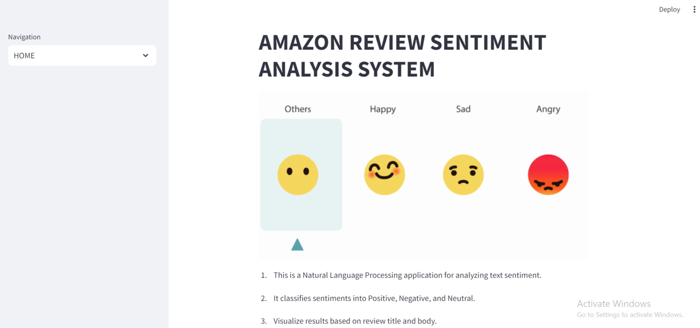

**Screenshot 2**

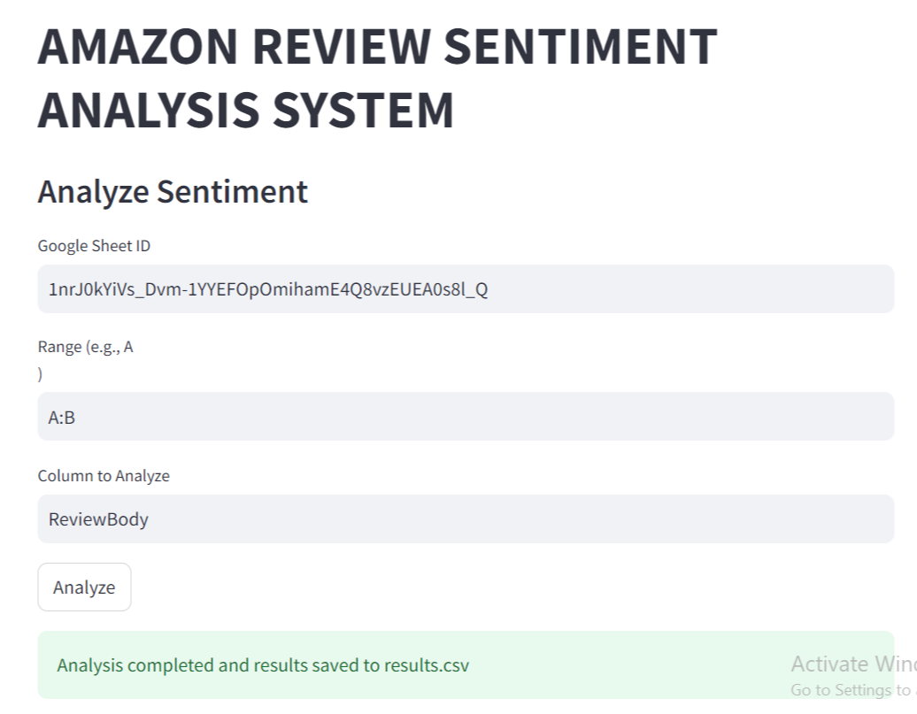

**Screenshot 3**

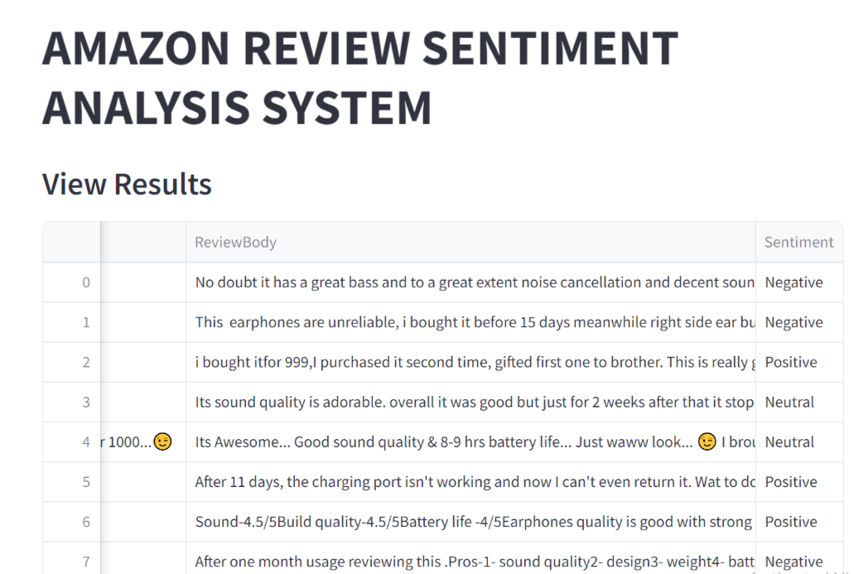

**Screenshot 4**

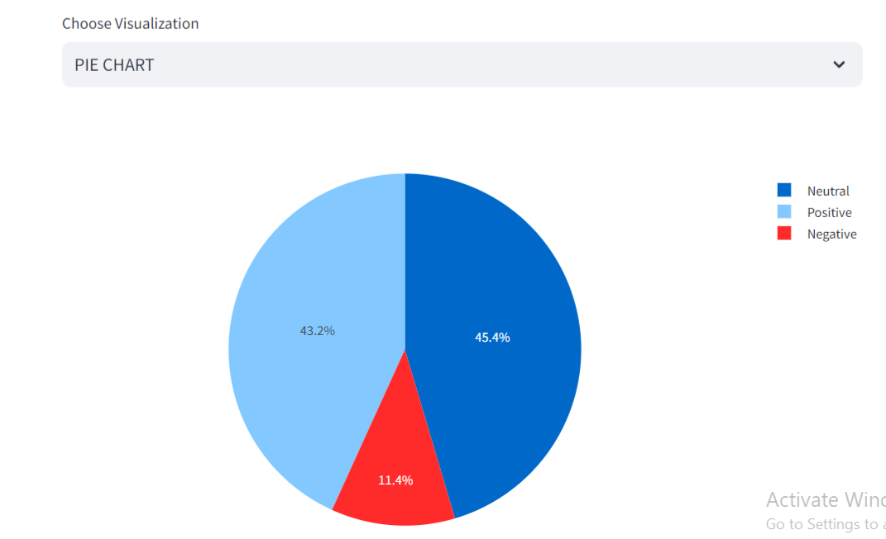

**Screenshot 5 (Hover on the Bars to see the total no. of count)**

